Guides for Operating a Stepping Motor

Equipment Required:

1.Arduino Uno 2.31306-MS 3A full bridge stepping motor driver

3.Stepping motor 57BYGH213-25 4.HF60W-SL-24 switching power supply

5. breadboards, wires, latching switches, variable resistors……

(All of which are available in Prof.Spalding’s lab)

31306-MS and Arduino Uno wiring:

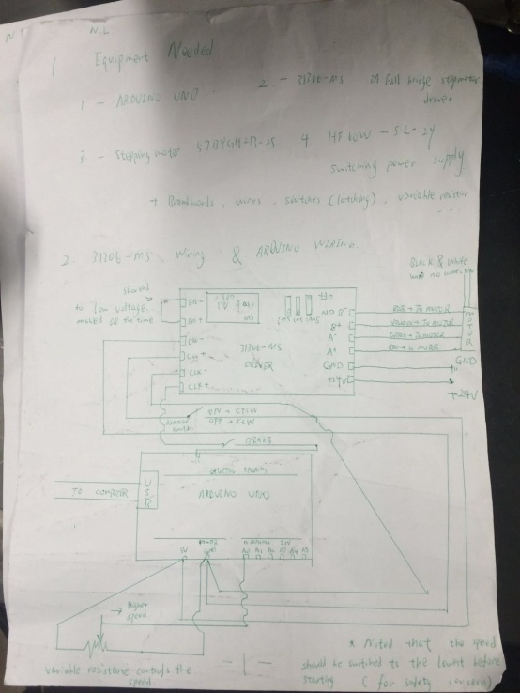

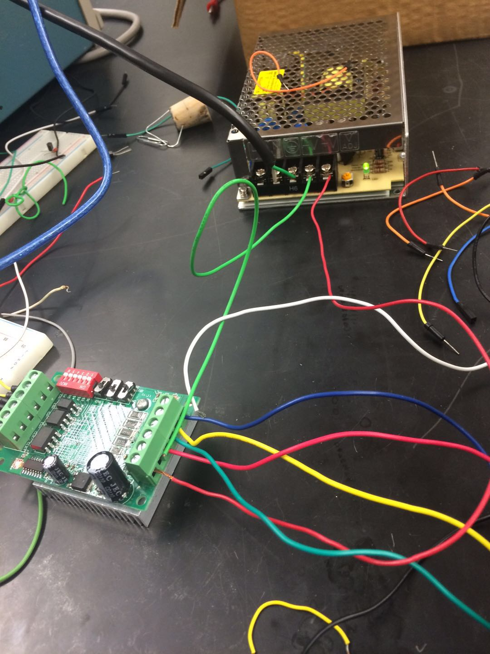

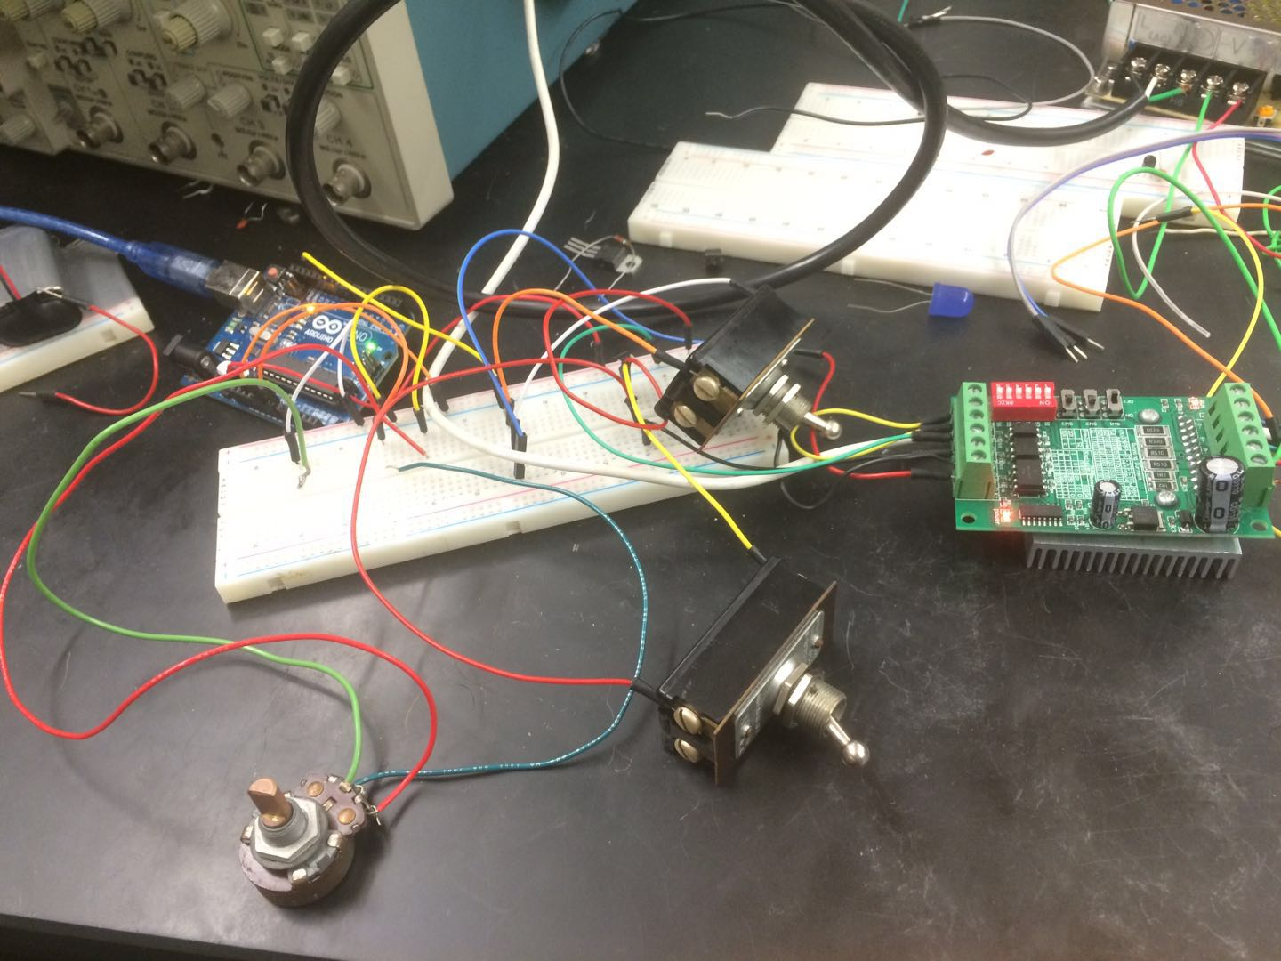

\*Note that I always switch CW- to low voltage while CW+ shall be switched (by one of the latching switches) between high and low in order to change the direction of spinning. (When CW+ is switched to high level (+5V), the motor will rotate counterclockwise)

\*EN+ and EN- shall be connected with the same wire in order to make sure that the motor is always enabled.

\*One of the latching switches is for direction controlling (when it is switched on, the motor goes counterclockwise) and the other is the brake (when it is off, the motor stops).

\*The variable resistor for speed controlling

HF60W-SL-24 Wiring

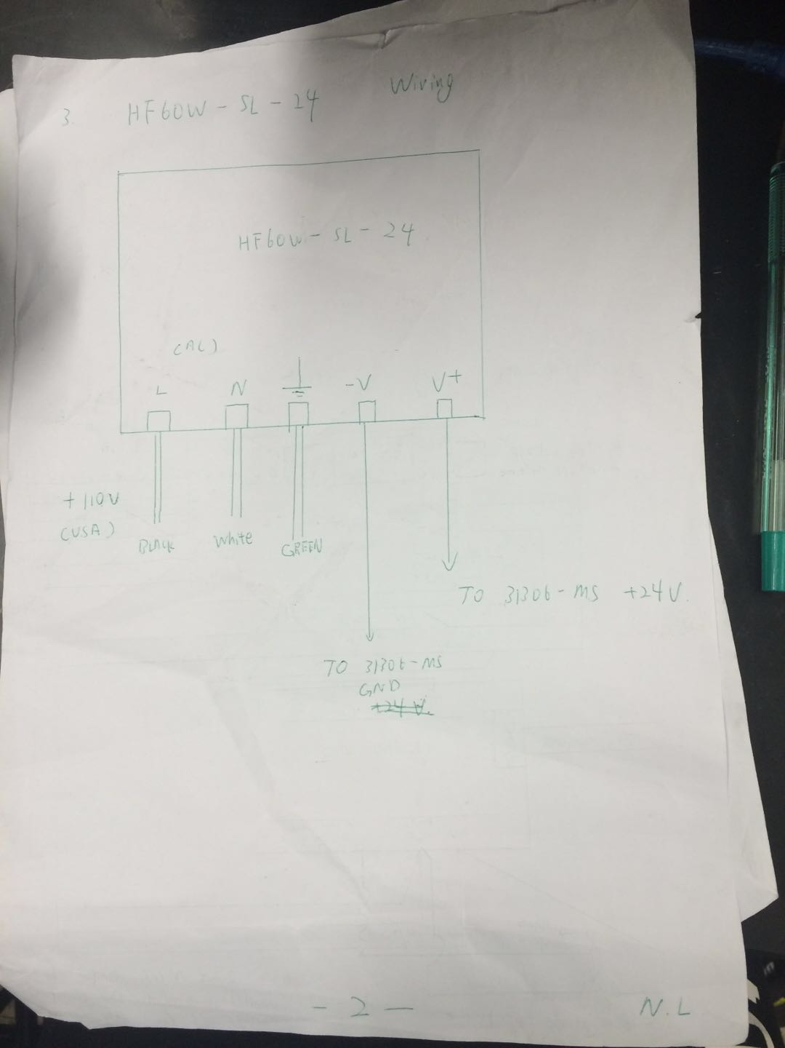

Coding:

void setup(){

Serial.begin(9600); //Set Port Rate

pinMode(A0,INPUT); //Set A0 to read the voltage

}

void loop(){

double x=analogRead(A0); //The voltage read may be controlled by the variable resistor

double t=x/10; //Just one simple algorithm

analogWrite(11,255); //Set CLK+ to HIGH level

delay(t);

analogWrite(11,0); //Set CLK+ to LOW level

delay(t);

} //Coding should be identical to wiring

PS: Hope these guides really help someone. If you have any question please contact Norman Luo, who is always ready to help.